**An overview of the e-Controls application in CST2021**

There are just several blank spaces to fill in such as:

1. ID information where FLC should choose the number and project title (all other information will fill in automatically).

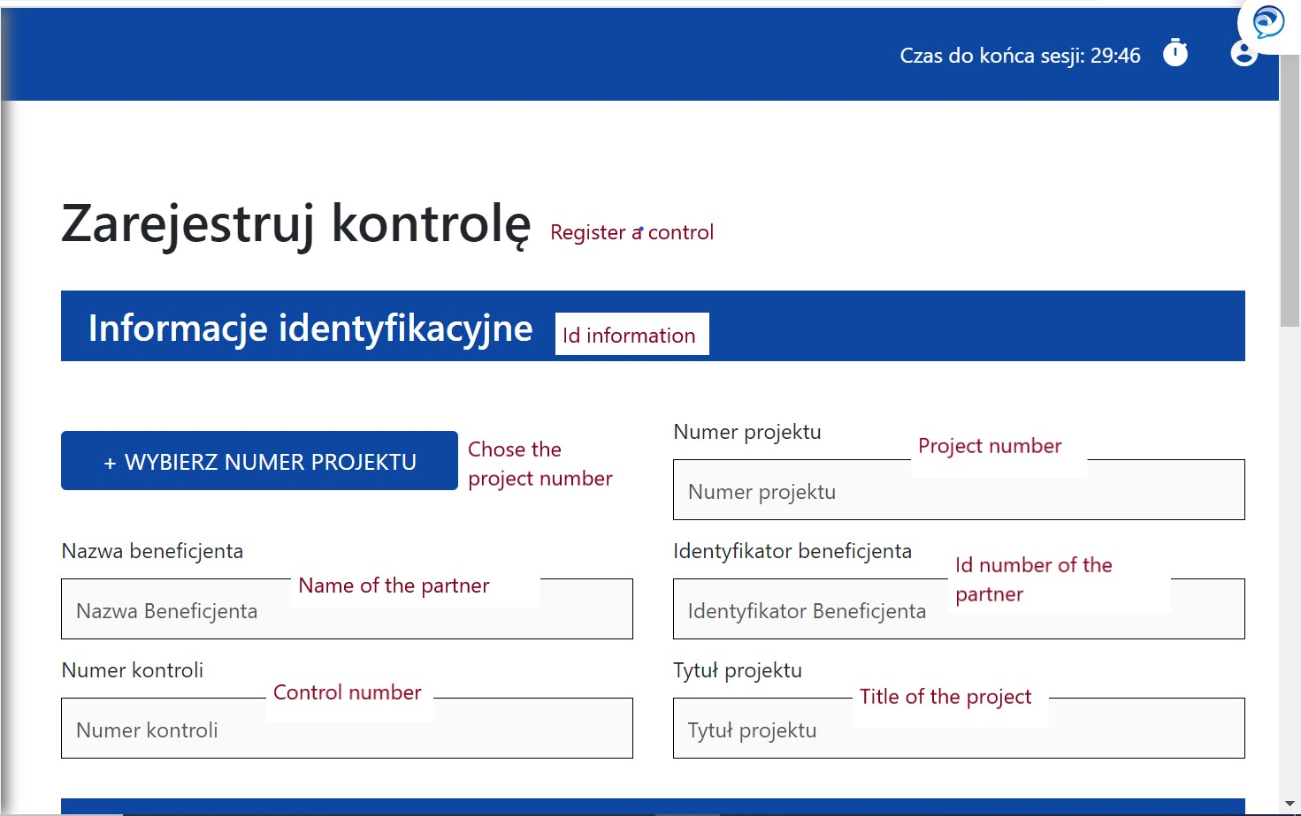

1. Information about control such as: name of the partner, name of the body which performed the control, date and type of control (also a box to tick if it was an audit of operation, other control and if it was a public procurement control).

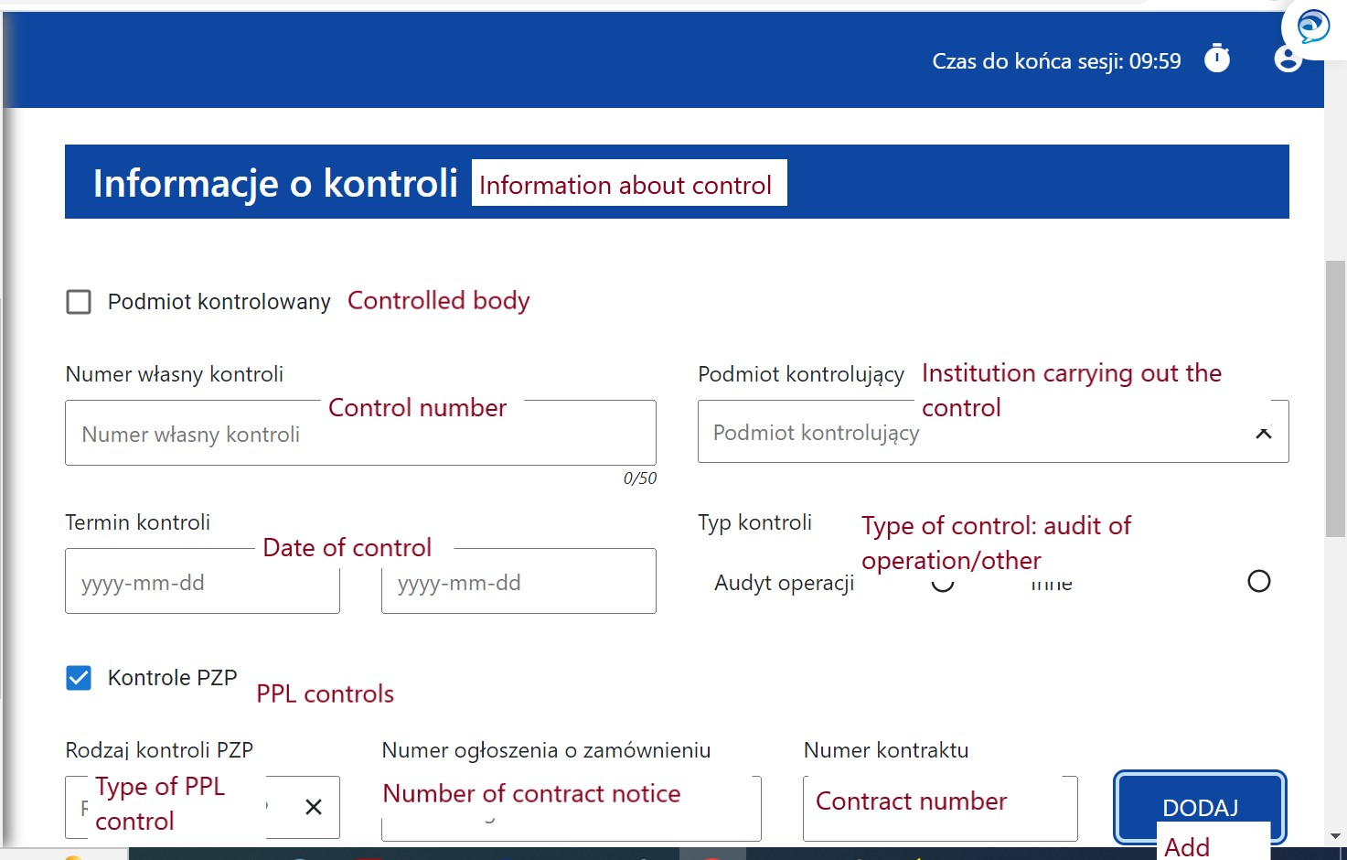

1. Results of control where FLC should indicate the result and short description.

